The History of the Land and the People that became ‘The Springs’
(Revision 2.0 – January 31, 2015)
The history of The Springs dates back as far as the mid-1830’s when Stephen Schooley registered the land with the United States Government in the Cincinnati, Ohio land office. The deed granted is signed by then President Martin Van Buren on November 7, 1837. Schooley received possession of the land in 1836.
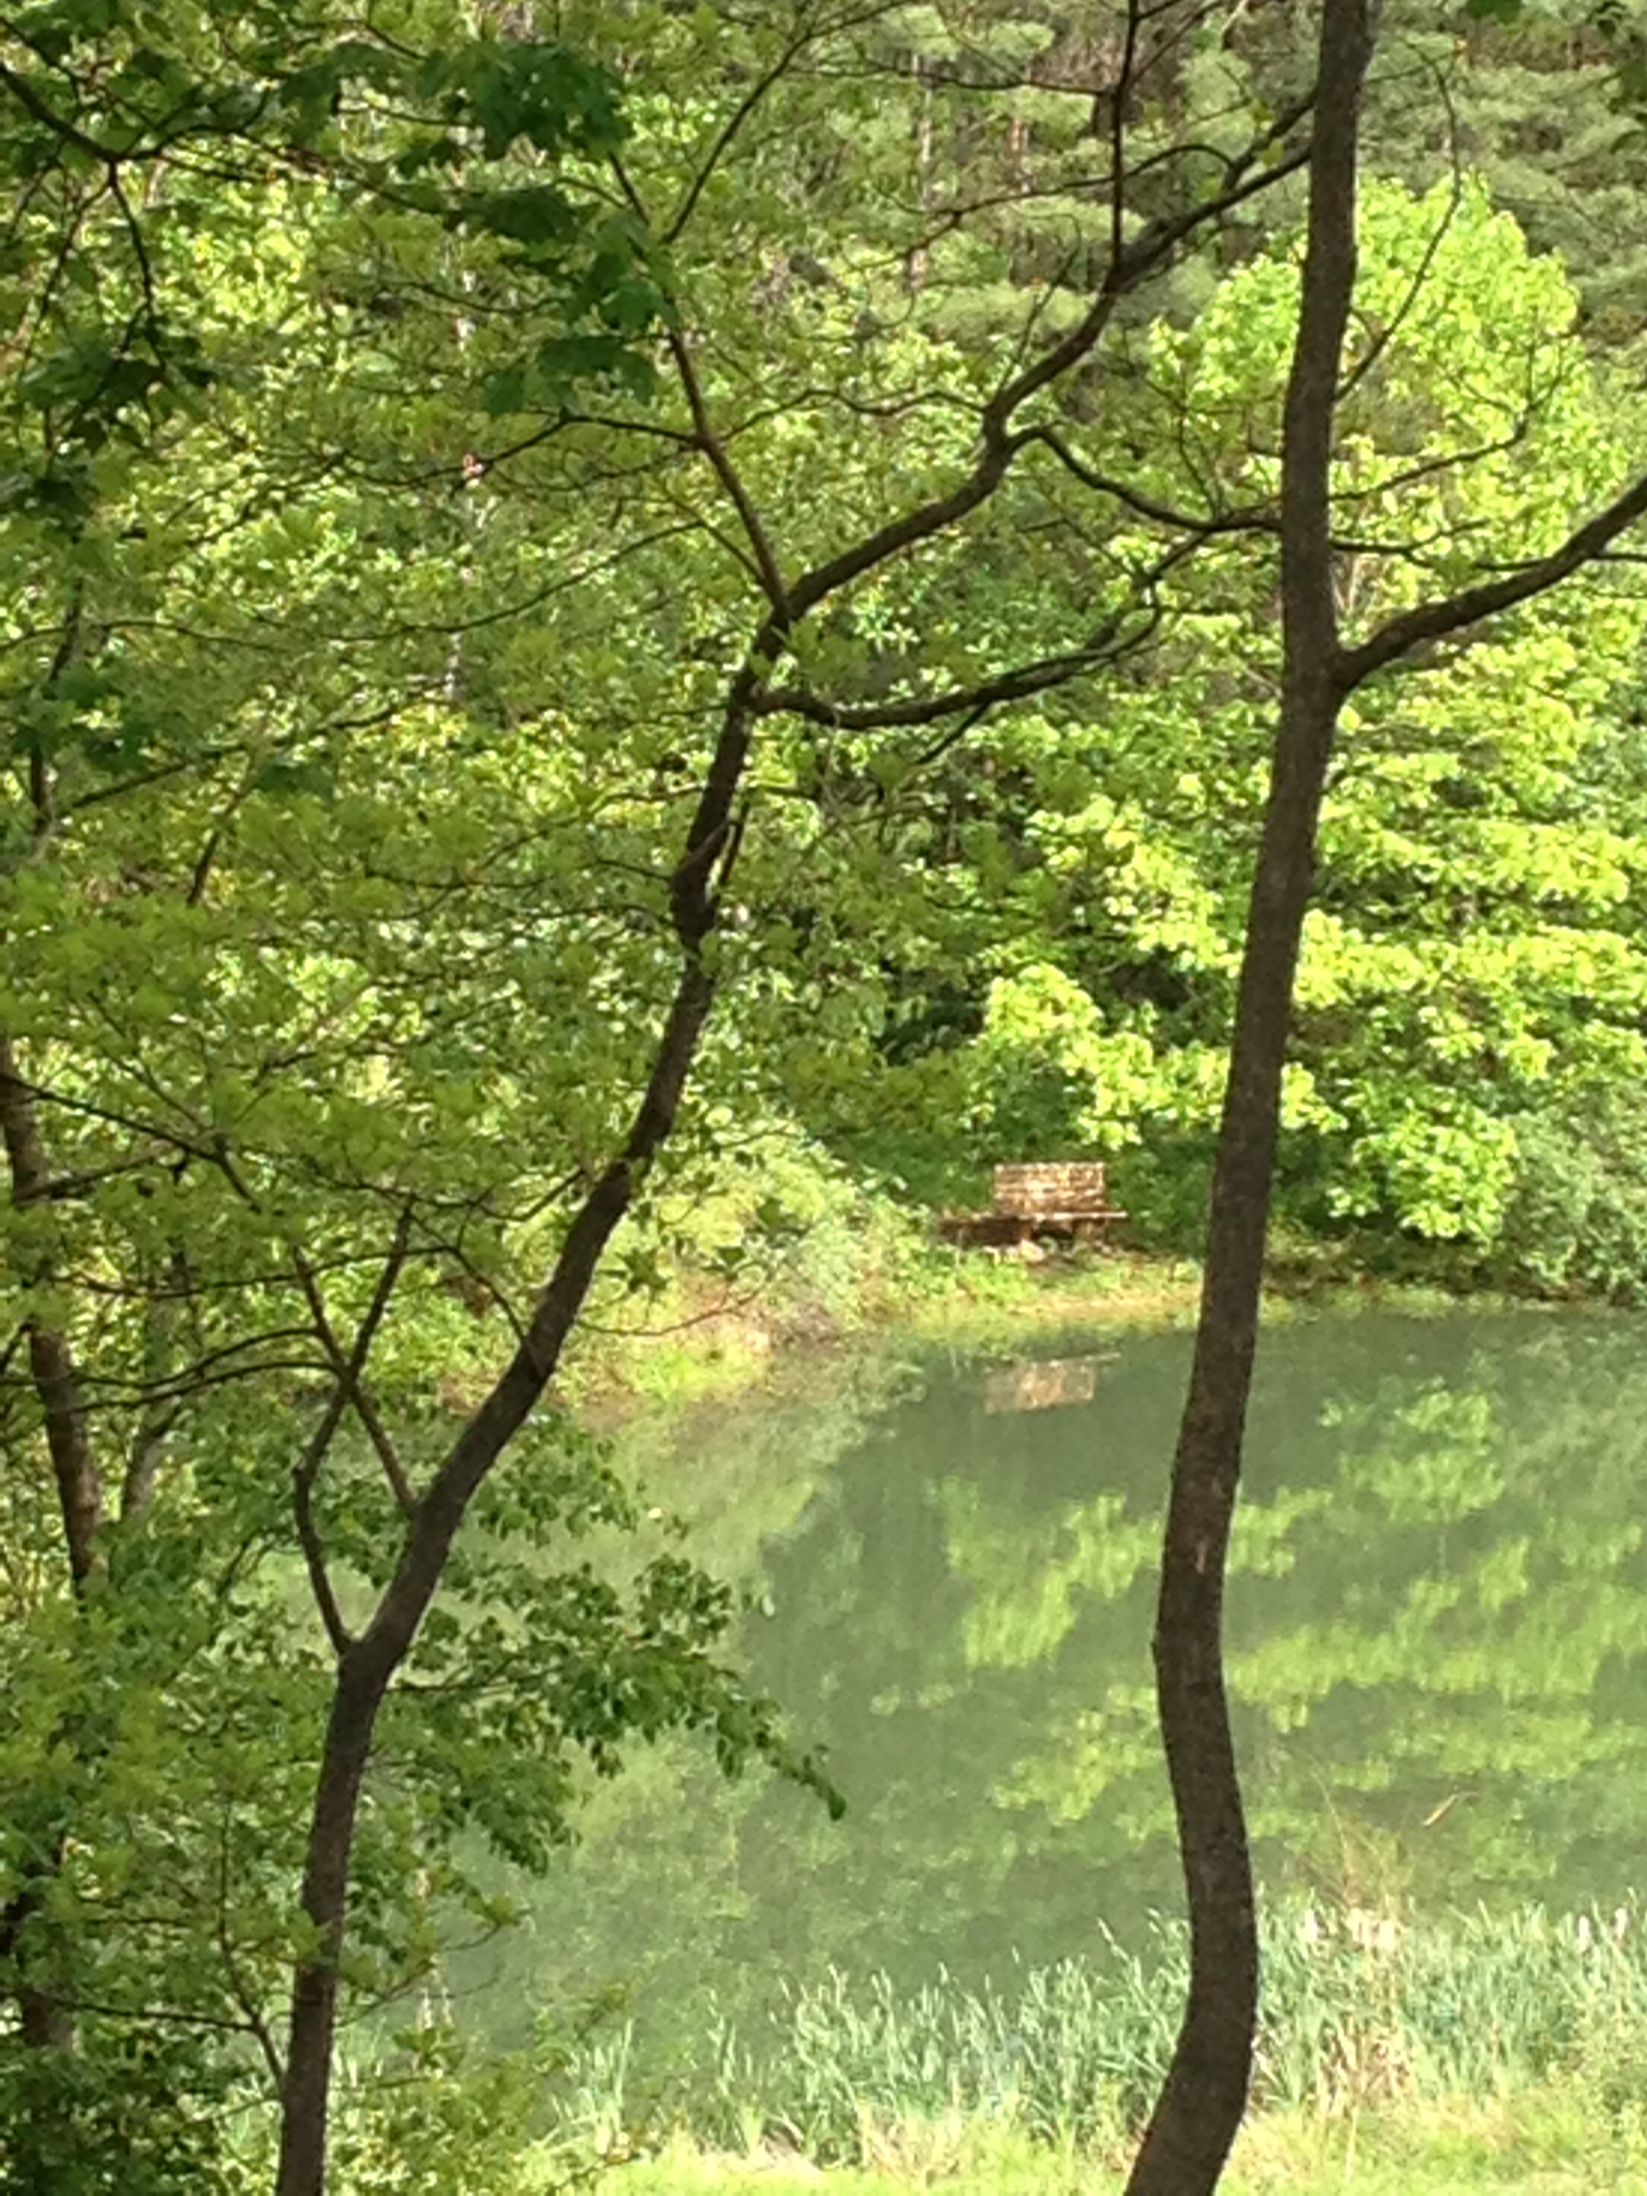
The 98.41 acres of land that eventually becomes The Springs is described as the Northwest Quarter of Section 7, in Township 11 of Range 12 - (7:11:12). The additional 49.87 acre parcel described as the Northeast Quarter of Section 12, Township 11 North, Range 11 East - (12:11:11)
Prior to 1830’s, Native Americans still occupied parts of the Indiana Territory. In 1809, the Treaty of Fort Wayne turned over some 3 million acres of Indian lands to the United States. Tribes such as the Miami, the Delaware, and the Shawnee were known to hunt in the Southern Indiana Territory.

Stephen Schooley (Ownership: 1836 – 1837)
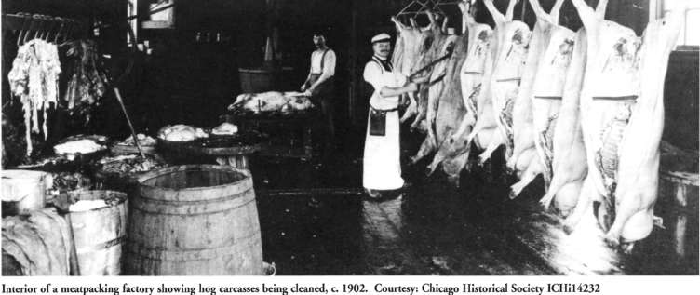
Born in 1795 in the part of Cincinnati known as the 25th Ward, Stephen Schooley was a successful businessman in Springdale, Ohio where he supplied goods to the soldiers during the War of 1812. In about 1818, he commenced business as a ‘pork packer’ and shipped it to Cincinnati in wagons. In 1832 he moved his business to the corner of Ninth and Broadway and relocated later to Court Street, west of Vine Street. He was known as one of the pioneers in the Cincinnati Specialty of Pork Trading. His sons were a part of the family business.
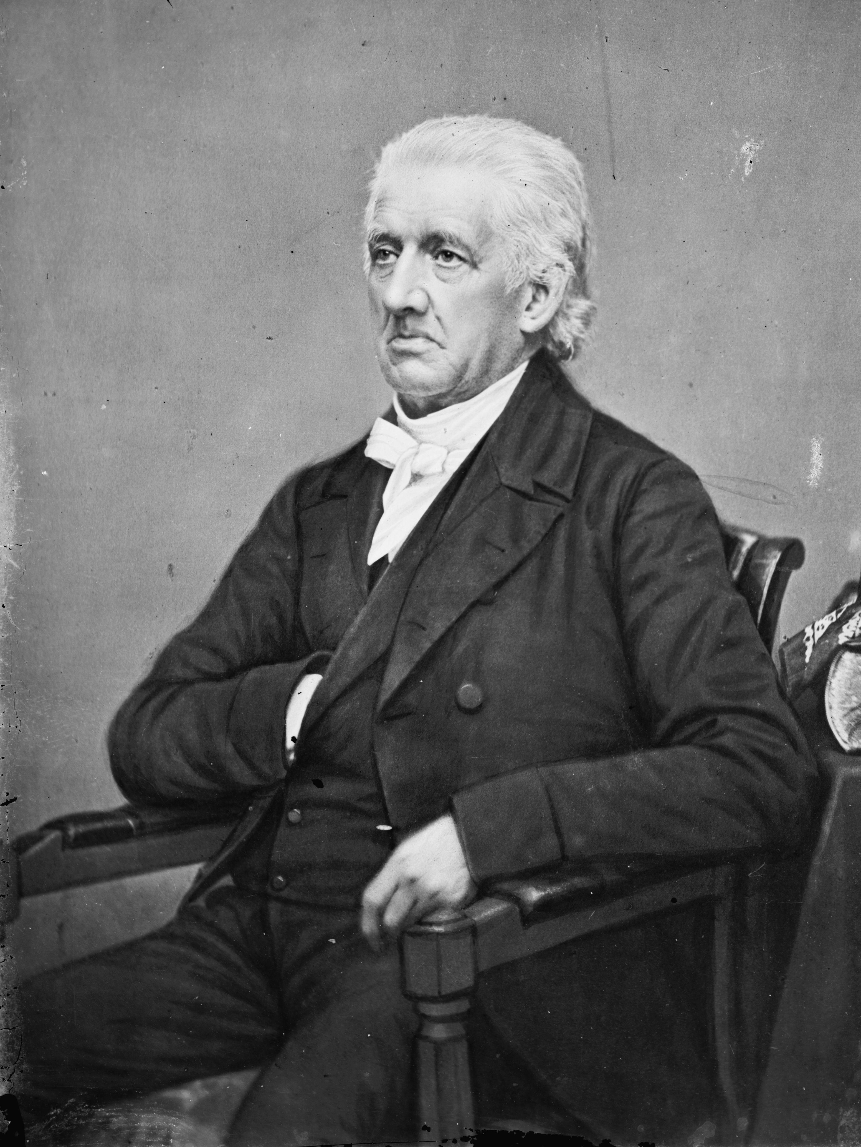
In 1820, Mr. Schooley married Miss Susan Duffield of Bedford County, Pa. They had 6 children. In 1832, The Schooleys joined the Second Presbyterian Church in Cincinnati (it eventually became the Covenant Presbyterian Church) where the pastor was Dr. Lyman Beecher (father of Harriet Beecher Stowe) who was the president
Lyman Beecher

and professor at Lane Theological Seminary in Cincinnati, Ohio. Stephen Schooley died on May 18, 1874 at the age of 79 in his home in Mt. Auburn, Cincinnati. His obituary stated that “he belonged to the last generation of businessmen, but those that survive, speak of his business capacity and general integrity in the highest terms.” His is buried in Spring Grove Cemetery (Sec. 36 Lot 89) in Cincinnati, Ohio.
(Source: GenealogyTrails.com, Spring Grove Cemetery Records)

William and Eliza Scudder (Ownership: 1837 - 1838)
The property transferred ownership from Stephen Schooley to William Scudder in December of 1836. The noted sale price was $2,574.20 and consisted of two large pieces of property. The sale was witnessed by the then Clerk of the Common Pleas Court of Cincinnati, William Henry Harrison, the future president of the United States. William and his wife Eliza were from Cincinnati in Hamilton County, Ohio.

Elias and Rhoda Ward (Ownership: 1838 – 1846)
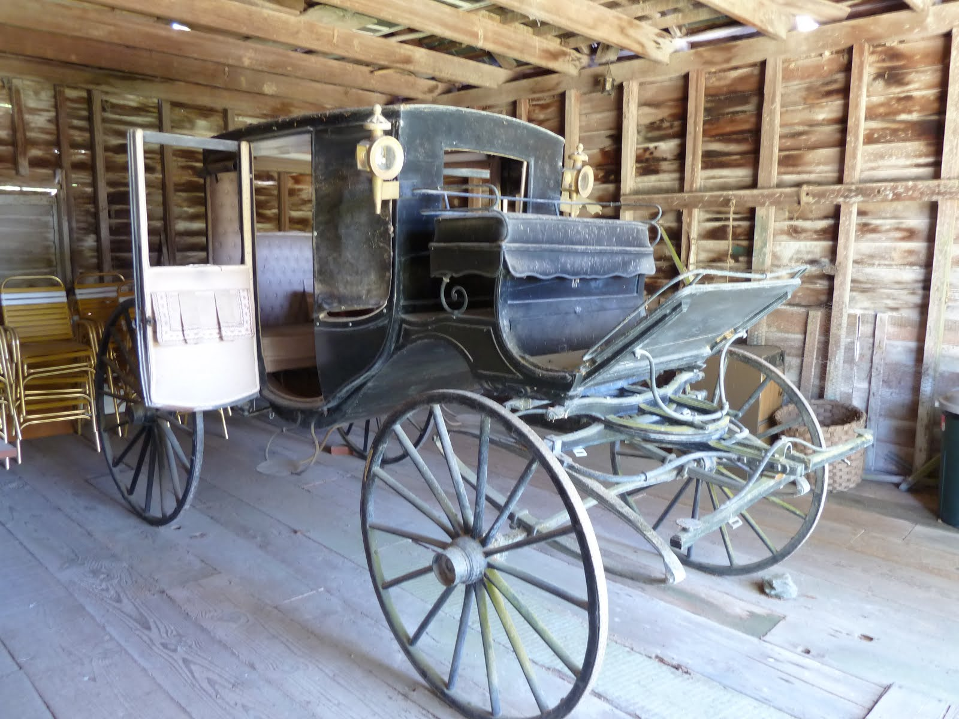
Born in 1786, Elias Ward was the son of Israel and Sarah Ward both of Morris County, New Jersey. In 1807, he married Rhoda Miller also of Morris County, New Jersey. They had 13 children in total. His initial profession was that of a harness maker. In 1811, Elias and Rhoda moved to Madisonville, Ohio where he practiced his trade as a carriage trimmer. A carriage trimmer was the craft that essentially built the inside elements of a carriage using leather, silks, and other materials. In 1832, he moved his business into Cincinnati where he lived for several years. In 1841, he bought land at Stipps Hill in Franklin County, Indiana, and moved there with his family. According to an article found in an old Franklin County Indiana History Book, "Stipps Hill was an important little interior point in the early days of Salt Creek Township in Franklin County."

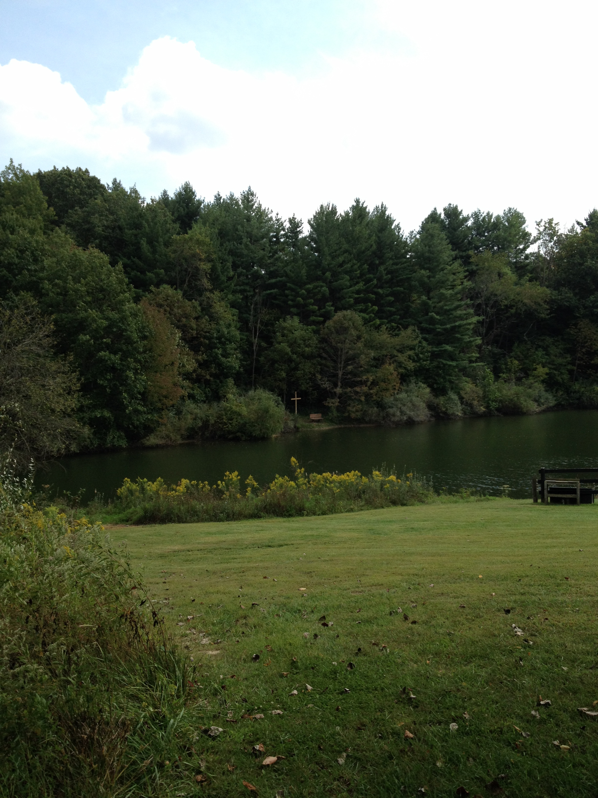
Elias Ward, whose ancestors had been good old Presbyterians in New Jersey, was a staunch Methodist and the first church services at Stipps Hill were held in his home. (This home was likely on the property later known as The Springs.) He was instrumental in having a meetinghouse built and a circuit preacher obtained so regular religious services might be held. This was likely a ‘Methodist-Episcopal’ Church and Elias and Rhoda were known for their Christian training of their children. They left Franklin County for Illinois in 1864 where Rhoda died in 1868 and Elias died in 1870.
(Source: Genealogy.com and Genealogytrails.com)

Elias purchased the land from William and Eliza Scudder in October of 1837. It totaled approximately 269 acres and the sale price was $807.00. This sale was witnessed by the future President of the United States, William Henry Harrison, who was serving as the Clerk of Courts, Cincinnati, Ohio.

Israel Ward (Ownership: 1846 – 1850)
Born on May 15, 1823, Israel was the seventh child of Elias and Rhoda Ward, Israel purchased the property from his parents in 1846. He married Julia Hurd. He followed in the same profession that his father had, carriage trimmer. He died on December 7, 1856 at the age of only 33 years old.
(Source: Genealogy.com and Genealogytrails.com)

Israel Ward purchased the land for $400 from his parents, Elias and Rhoda Ward in January 1846. He owned the land for about 5 years before selling it to Jacob and Jasinah Magill.

Jacob and Jasinah Magill (Ownership: 1850 – 1865)

Jacob N. Magill: Born: July 21, 1825, Died: November 13, 1905
Jasinah Anna (Bateman) Magill: Born: February 1832, Died: October 18, 1903
Both have their final resting place in Spring Grove Cemetery in Section 88, Lot 15.
(Source: Spring Grove Cemetery, Ancestry.com)

Jacob and Jasinah Magill purchased the land from Israel Ward in September of 1850 for the price of $445.00. He only purchased the 109 acres of the NW Section 7, Township 11, Range 12 East. His daughter Charity Magill was born at the time when the Magills were living at ‘The Springs’.

Hugh, Elizabeth, and Sarah Weston (Ownership: 1865 – 1876, 1876 – 1892)

Hugh Byron Weston: Born: January 16, 1843, Died: April 14, 1915

(1) Rachel (Abraham) Weston: Born: September 8, 1852, Died: February 28, 1871
Children: Sarah Elva Weston: Born: June 22,1870 Died: August 11,1893

(2) Elizabeth (Colter) Weston: Born in 1844, Died in 1904.

After serving in the Union Army, Company A, 123rd Indiana Infantry from November 18, 1863 until August 25, 1865, Hugh Weston returned home to Franklin County and purchased the property from Jacob and Jasinah Magill in October of 1865 for the price of $1100.00.

Hugh married his first wife, Rachel (Abraham) Weston from Franklin County Indiana and they had their only child, Sarah in June 1870. Rachel died some eight months later. The cause of death is unknown at this time. Hugh married for a second time to Elizabeth (Colter) Weston, who helped to raise little Sarah. Sarah, who never married, died at the young age of 23, cause unknown.
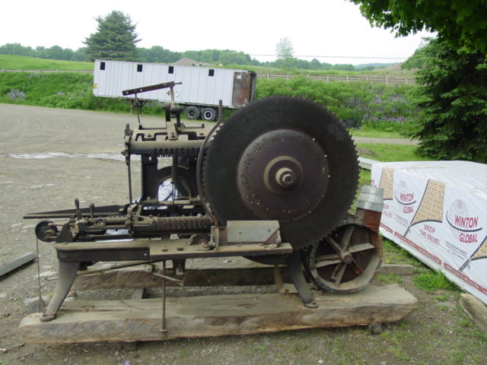
Hugh Weston apparently had a ‘shingle machine’ on site, which may have been a source of income for the family. This is noted on the 1867 Map of Salt Creek Township. The Grand Army of the Republic post at Metamora, Indiana was established in 1884. Hugh was a member of this post.

Hugh and Rachel made the original purchase of the property in 1865 and for some reason, in 1876, Hugh sold the property to Fletcher Ailes and then Elizabeth and Sarah Weston repurchased the property within 9 months. I’m not clear what the cause of this transaction was. The Panic of 1873 created a depression in the United States up until 1879 and may have been a cause for the short sale of this property.

In 1892, Elizabeth transferred the property to the Sarah Weston Trust and then a day later the property was returned to Hugh Weston. The property was then sold to Daniel Volk in late 1892.

Fletcher Ailes (Ownership: 1876)
Aaron Ailes and his wife Elizabeth (Duvall), parents of Fletcher, moved to Franklin County from Pennsylvania in 1837 and settled on a farm. Along with farming, he opened his home for ‘religious services’ and itinerant preachers always found a hearty welcome at his fireside. They had a large family of 11 children of which Fletcher was the 10th. Born on May 12, 1835, Fletcher grew up in Franklin County. He fought as a Union soldier as a part of the 37th Indiana Infantry and had the rank of Corporal B. He married Louisa (Wolfe) in 1867 and together they had 4 children. Fletcher died in 1899 and Louisa passed in 1924.

As mentioned previously, Fletcher purchased the ‘property’ for a short time in 1876 for the sum of $500. In addition, he took out a mortgage for $237, which was held by William Pruitt. Some 8 months later he sold the land back to Elizabeth Weston for $600 and transferred the mortgage to the Westons. It is not know for certain whether the Depression of 1873, which lasted until 1879, had anything to do with the agreement between Fletcher Ailes and Hugh Weston, but it is feasible that Weston was facing a short-term financial crisis, which Ailes helped alleviate by holding the land for 8 months.

Daniel Volk (Ownership: 1892 – 1912)
Daniel Volk was born in Enochsburg in Franklin County, Indiana on March 1, 1865. He was married twice, first to Lizzie Niehoff in November 1891.

His second marriage was to Elizabeth Ricke in July 1932. Both of his wives preceded him in death. Daniel died in April 1944 at the age of 79. He served as a Franklin County Trustee for many years representing Salt Creek Township.
(Author’s note: Our current neighbor down the road, Mike Peters, fills this role today representing Salt Creek Township.)

In December 1892, he purchased two pieces of land from Hugh Weston totaling 159 acres for a price of $1900.00.

Joseph Herbert (Ownership: 1912 – 1921)
Born in Dearborn County on November 18, 1863, Joseph was the son of Matthew (Mattaus) and Barbara Herbert. Matthew immigrated to Indiana from Germany where he was a harness maker. After Matthew died, his wife Barbara (who was from Dearborn County) went to live with Joseph who lived on the farm adjacent in Salt Creek Township, Franklin County, Indiana. Joseph learned at an early age how to farm and was ‘bounding wheat’ by age eleven. After purchasing the 109 acre land that is currently “The Springs” from Daniel and Lizzie Volk for the price of $1500.00 and he erected a new home and barn and farmed the land along with raising livestock.

Joseph married Katherine (Katie) Klein of Oldenburg on April 23, 1890. Together they had six children. Joseph and Katie were members of St. Anne’s Catholic church at Hamburg and took an active interest in the works of the parish.
(Source: History of Franklin County Indiana by August Reifel)

James and Mary Blake (Ownership: 1921 – 1960)
James Tandy and Mary (Shepherd) Blake were the longest residents of the property on Davison Road, residing there more that 39 years. They purchased the property from the Herberts in March of 1921 for $65, significantly lower than the price paid by all previous owners. One wonders what might have been happening at that time in the lives of the Herbert Family.

James T. Blake was born in the state of Kentucky in the year 1881. Mary also was born in Kentucky the year before James, in 1880. Together they had 10 children. At the age of 40, James purchased the property on Davison Road.

Ruby D. Simpson (Ownership: 1960 – 1964)
Ruby D. Simpson was one of the daughters of James and Mary Blake. Born in 1908 in Kentucky, she moved with her family to Indiana and purchased the property from her parents in April 1960.

Thearn and Jessie Peterson (Ownership: 1964 – 1965)
In May of 1964, Ruby Simpson sold the property to Thearn and Jessie Peterson. Thearn died in 1977 at the age of 75, but Jessie lived to be 98 years old, just three months shy of her 99th birthday. They were married in London, Kentucky on July 11, 1934. Jessie worked for Hillenbrand in Batesville for several years, but spent most of her life as a homemaker.
Source: Find a Grave website and Gilliland Howe Funeral Home Obituary.

Robert and Joanie Currence (Ownership: 1965 – 1989)
In 1965, Robert and Joanie Currence had a strong desire to purchase land out in the country. While living in Cincinnati, they purchased the property at 8173 Davison Road from Thearn and Jessie Peterson and for the first three years, the Currence Family, including their daughter Debbie spent time at what would become “Amber Oaks” and stayed in a camper that remained on the site.

During the period of 1965-1968, a “3-acre” lake was created by Urban Nobbe in exchange for two acres of land that was owned by Robert Currence. The lake is spring fed and to avoid erosion, Joanie planted ‘Crown Vetch’ around the lake. For five years, Joanie planted 2000 pine trees a year, totaling 11,000 pines planted on their 500 plus acres of property.

The current home (or a portion of it) was built in 1968 and was a Total Electric Living Home. It was built by Dave Schwering and had a used brick exterior and was a two-bedroom home. An addition was built later along with an in-ground pool.

The daughter Debbie recalls when they were raising cows, that one winter day, one of the calves was quite ill and was not able to stand. To help keep the calves warm, a space heater was placed in the old barn that used to stand just above the current “Gathering Space” on the hill, and the calf stood up and knocked over the heater and subsequently, the barn burned to the ground.
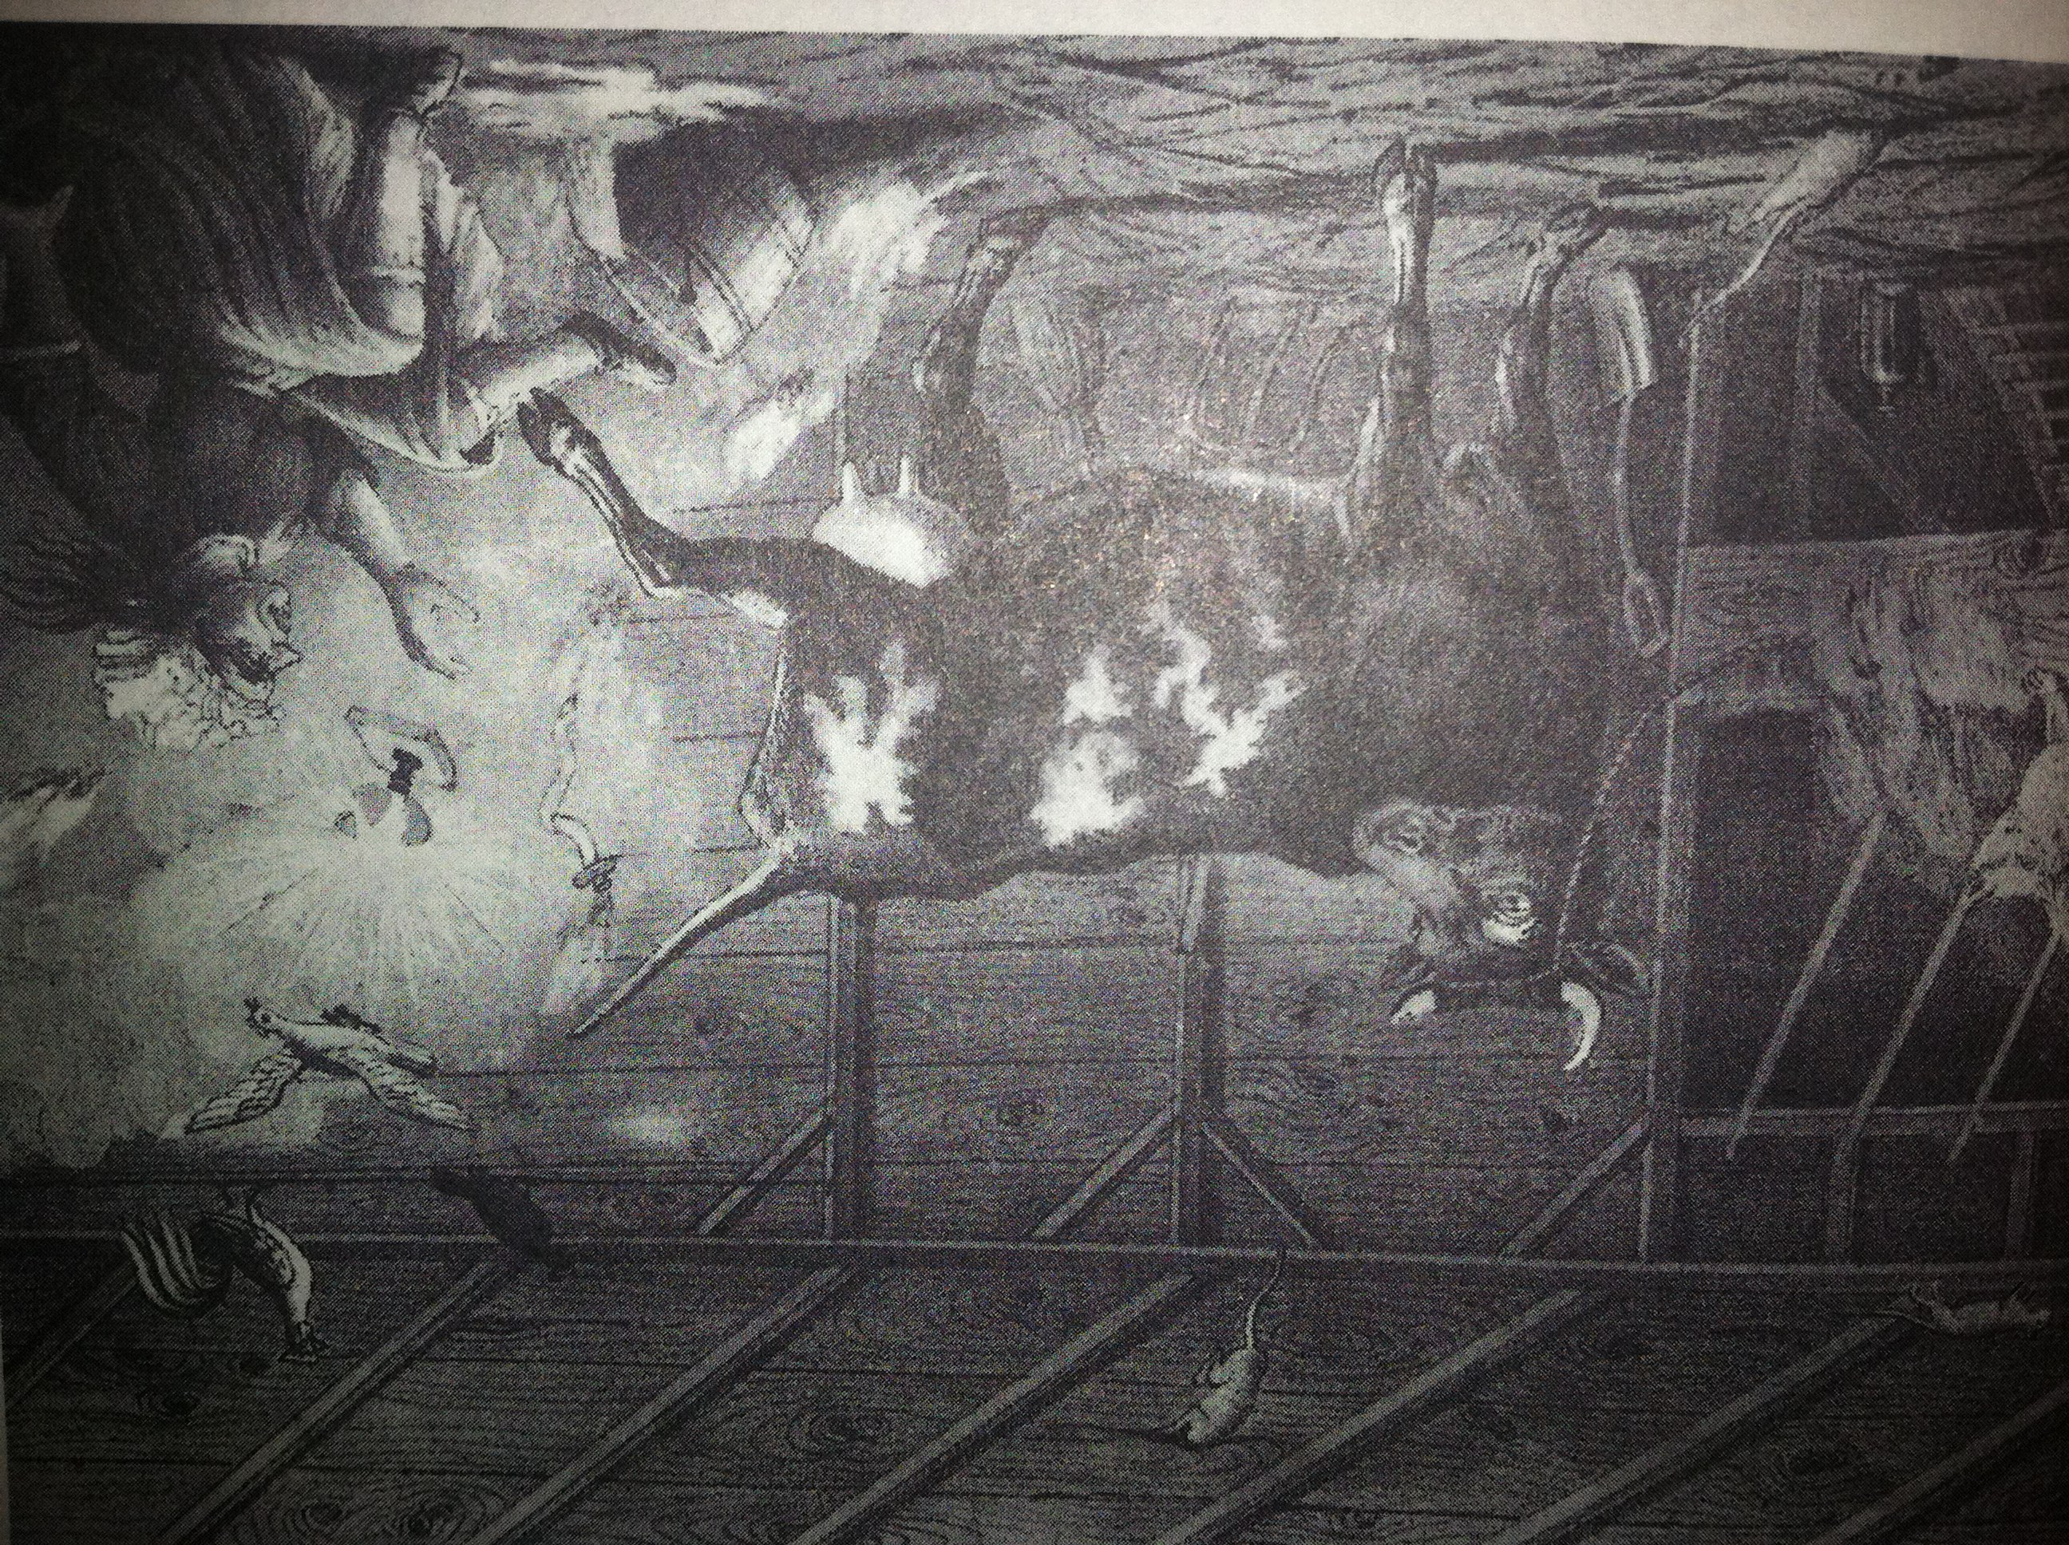
(I wonder if the cow was related to Mrs. O’Leary’s cow from Chicago??)

In 1976, Debbie was married on the Gazebo steps overlooking the lake. Debbie and her first husband then built a stone home just off Red School Road on property bought from her parents. In 1980, Joanie passed away at the age of 47 and was buried in the Holy Family Cemetery in Oldenburg. Following Joanie’s death, Debbie and her husband moved into the Davison Road home until their stone home was completed. At that time, Robert moved in with Debbie and her husband. Robert passed away in 1995 having died in a fire in his home. From about 1981 through 1989 the home was vacant and fell into significant disrepair.
Source: Interview with Debbie Enneking, October 10, 2014

Vernon and Phyllis King (Ownership: 1989 – 2010)
In 1989, Vernon and Phyllis King purchased the home and the land at 8173 Davison Road from Robert Currence. They had dreams of caring for horses and finding peace and serenity in the country. Vern had been a property developer and had plans to renovate the current home along with addition additional barns for the horses and for maintenance equipment.

Formation of “King’s Ranch” (Ownership: 1999 – 2010)
In 1999, Vern and Phyllis sensed the prompting of the Lord to provide a place for ‘Stressed and Burned Out’ Pastors. In their own words,
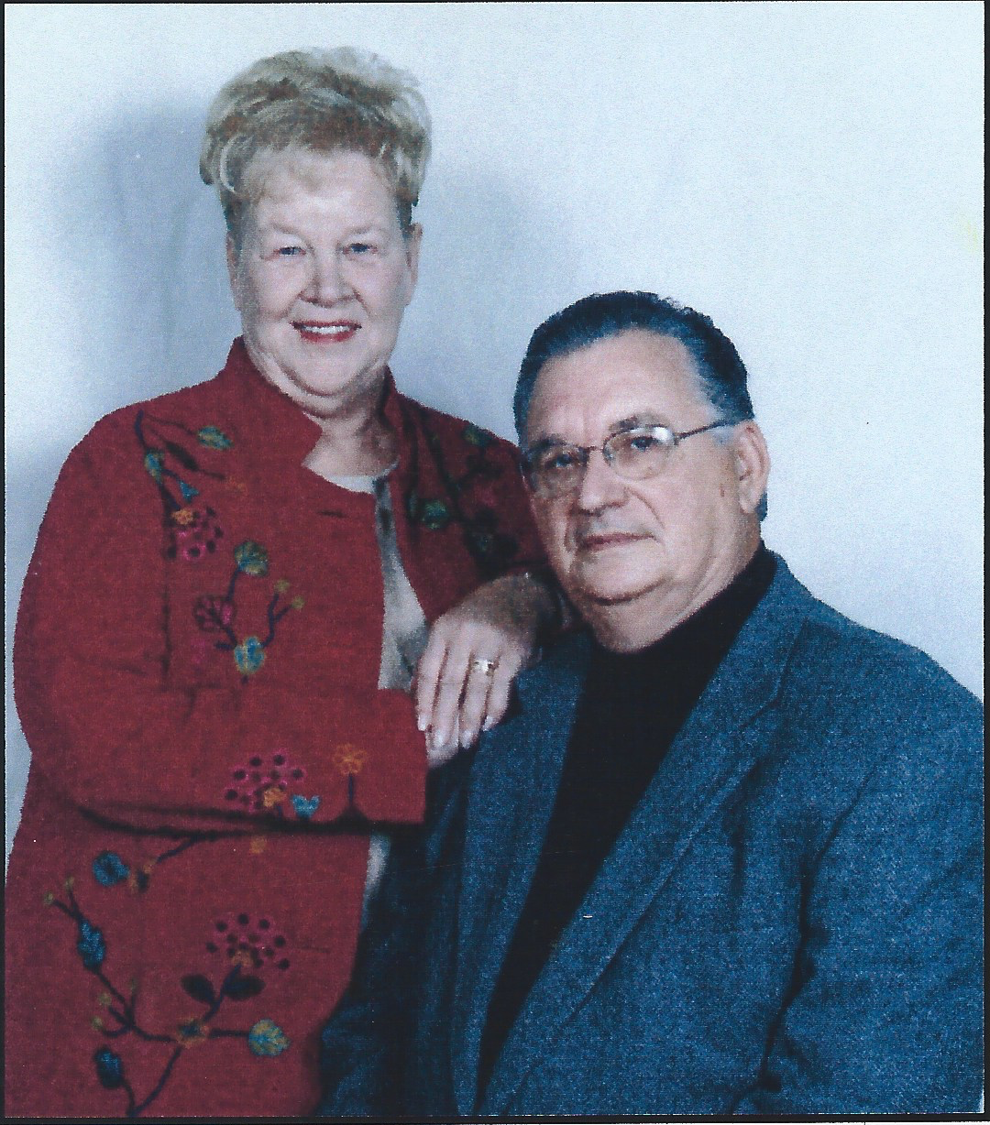
“Phyllis and I have felt led by the Lord to do what we can to ease the emotional pain and suffering for those in need by providing a place of tranquility where the hurting and tired can find rest from the pressures of their loads. It is our desire that those who visit with us will return to their ministries refreshed by the power of God and the great beauty of His creation in this place.”

In June of 1999, a new non-profit ministry was born and become known as “King’s Ranch”. On December 30, 1999, 148 acres of the land owned by Vern and Phyllis was transferred to Kings Ranch. On May 7, 2001 the IRS granted King’s Ranch it’s formal 401c3 Operating Private Charity status!

The King’s Ranch, Inc. Statement of Purpose read as follows:
“King’s Ranch will provide to minister and their families of any Christian origin, a safe haven for rest, recovery, or restoration from stress, due to the responsibilities of leading and developing their related ministries.”

In order to help bring this vision and purpose into reality, King’s Ranch built the first two of it’s eventual four ‘cabins’. These were completed by about the year 2000 and two more were built in 2005. The four cabins were beautifully furnished and built with fully equipped kitchens. For the next 5 years, Vern and Phyllis provided an ‘Oasis for Renewal” to all that came to King’s Ranch.
Source: King’s Ranch Cabin Notebook written by Vern and Phyllis King.

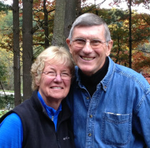
Dick and Sibyl Towner (Ownership: 2010 – present)
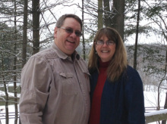
In the fall of 2009, Dick and Sibyl Towner sensed a draw back to the Cincinnati area having spent 17 years in Chicago. Their search for a home in the country with a small lake led them to King’s Ranch. Little did they know what God had in store for them! Their small home and lake would became a 150 acre Christian Retreat Center with a 2 plus acre lake! As they began to pursue the property along with their initial partner, who had discovered the property, they were able to make an offer to the King’s for their home and the ministry. However, just prior to ‘closing the deal’, their partner, ran into financial challenges and had to pull out of the partnership. At this point, Dick and Sibyl sought the Lord on what to do about the situation and were led to share their situation with Skip and Linda Holmes, long time friends and partners in previous ministries (and current owners of the home they left in Cincinnati in 1992). After much prayer and a Skype call with Skip and Linda who were on assignment in Bangkok, Thailand with Procter & Gamble, the four agreed to pursue the purchase of King’s Ranch and the private home that was on the property. In July 2010, Dick and Sibyl purchased the home at 8173 Davison Road, Oldenburg, Indiana and began the renovation and expansion of the home. In August of 2011, they officially relocated from Elgin, Illinois and moved into their renovated Indiana country home.

Dick continues to co-lead the Good Sense Ministry that he founded in 1993 and Sibyl continues to lead the One-Life Maps Ministry and provides Spiritual Direction to many that come to The Springs.

Skip and Linda, as Directors of The Springs, continue to be involved in the daily ministry of the Springs through participation in helping to maintain the property, provide Spiritual Direction to some guests and assist in the overall development of the ministry. They currently live in Cincinnati, Ohio.

“The Springs” (2010 – present)
The formal transition of the Board of Directors from the Kings to the Towners and Holmes’s happened in July 2010. Shortly after that transition, the Board hired Jonathan Holmes, son of Skip & Linda Holmes, as the first “Operations Manager”. Jon moved to The Springs later that summer and began the work of restoring the site to its original luster and also provided oversight for the renovation and expansion of the home for Dick and Sibyl. Jon’s wife Pennie had moved to Cincinnati in June, but lived in the home of Skip and Linda while working in Cincinnati. Pennie would not relocate to The Springs until June 2011, just prior to the birth of their first daughter Stella. Pennie then became part of the operations team with Jon and took over responsibility for reservations and cabin operations. During Jon and Pennie’s time as the Operations Managers, they restored the site to an excellent state and led the effort to build a new Staff House. During that time, Workdays for Volunteers (later to be know as SOS Workdays – Sweat on Saturday) were instituted and led to the creation of many new spaces on site and improvement to current facilities. New additions included a volleyball court, horse-shoe pits, a labyrinth (graciously built by three generations of Towners), a picnic area, a dock for the lake, a relocated hot tub and hiking trails.
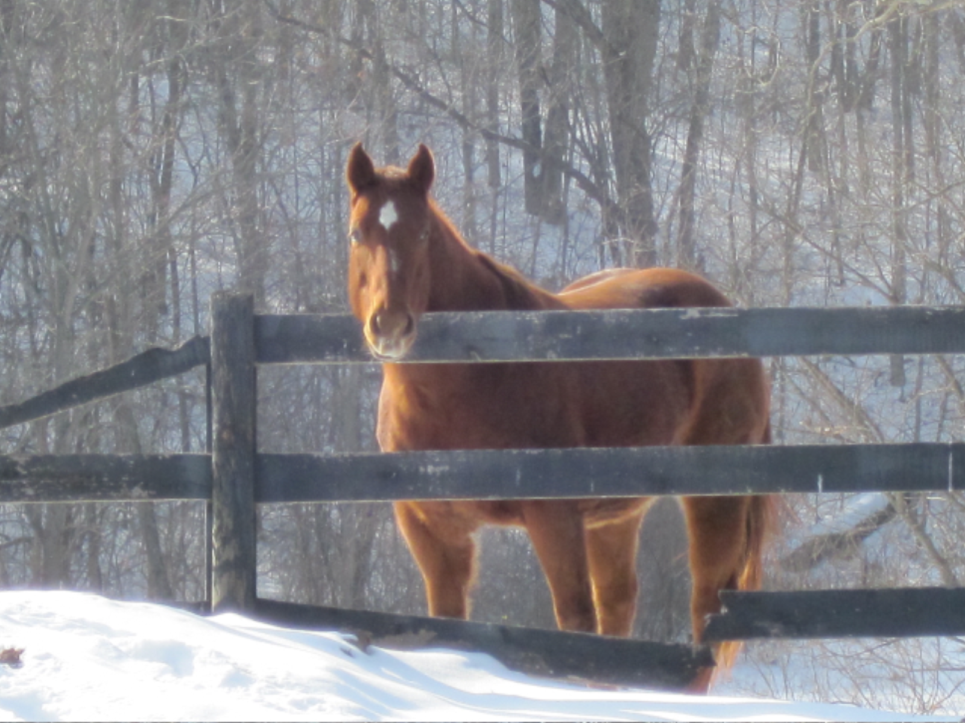
Animals have been a part of both King’s Ranch and The Springs since it’s inception. King’s Ranch had as many as 40 horses and several llamas. The Springs has had as many as 4 horses, 8 cats, and a dog. Today there are 2 horses and 2 cats along with additional wildlife of birds, deer, raccoons, possums, and foxes. In 2012, The Springs was certified as a wildlife habitat by the State of Indiana.
In January 2011, the Board approved a formal name change from King’s Ranch to “The Springs” with a tag line added, “A Place to Return To”. Further clarity of mission/purpose was given and the new mission statement reads as follows:
“The Springs is a Christian retreat center providing welcoming spaces for those in ministry to encounter the healing love and presence of God in order to serve with greater authenticity.”
Further work was done in 2012 to define the core values that guide the ministry:

God led, Guest Centered, and Creation Sensitive

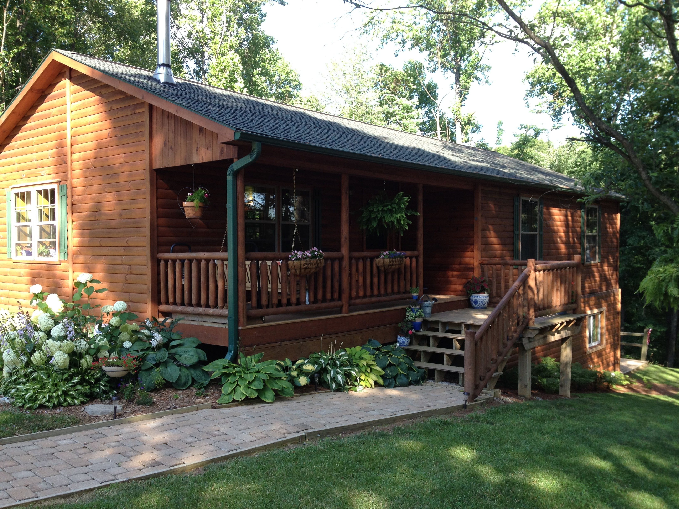
As 2011 progressed, several major changes came to The Springs. In July, a new member of the Springs Operations Team came on site. Stella Jane Holmes was born on July 5, 2011 and added to the joy and peace (?) of The Springs. Then later in August, a new Amish built pre-manufactured log home arrived from Pennsylvania built by Zook Cabins. This new 3-bedroom home became known as the “Staff House” and Jon, Pennie and Stella relocated from their temporary quarters in Cabin 2 into the Staff House in September.
The 3 Bedroom Staff House has a kitchen & great room, bathroom with a wood burning stove! It also has full basement to house the necessary operations of laundry, storage, and office along with a fully equipped suite for the directors.
In November of 2012, Jon, Pennie and Stella completed their roles as Operating Managers and moved back to the city to raise their growing family. (They now have two girls, Mollie joined the family in May 2013).
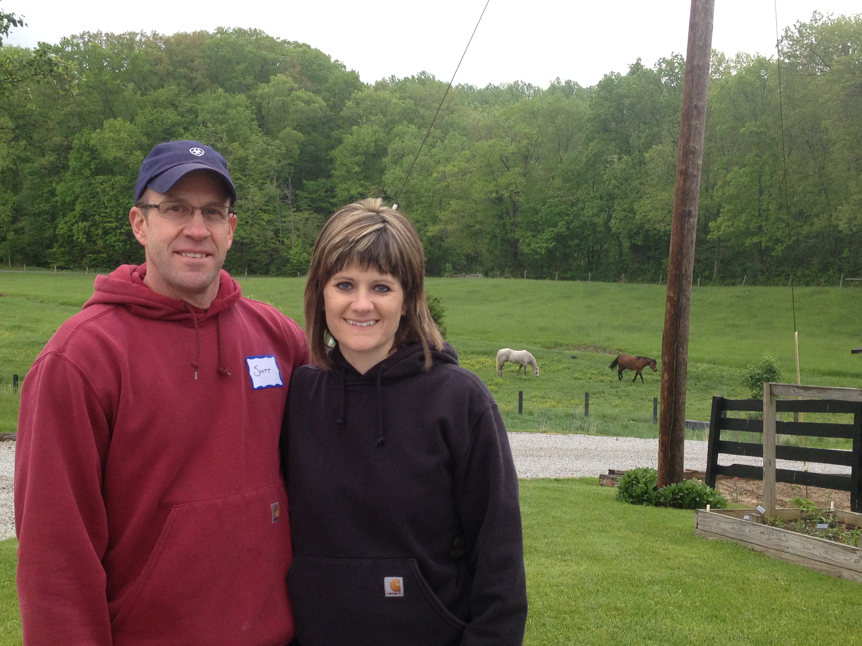
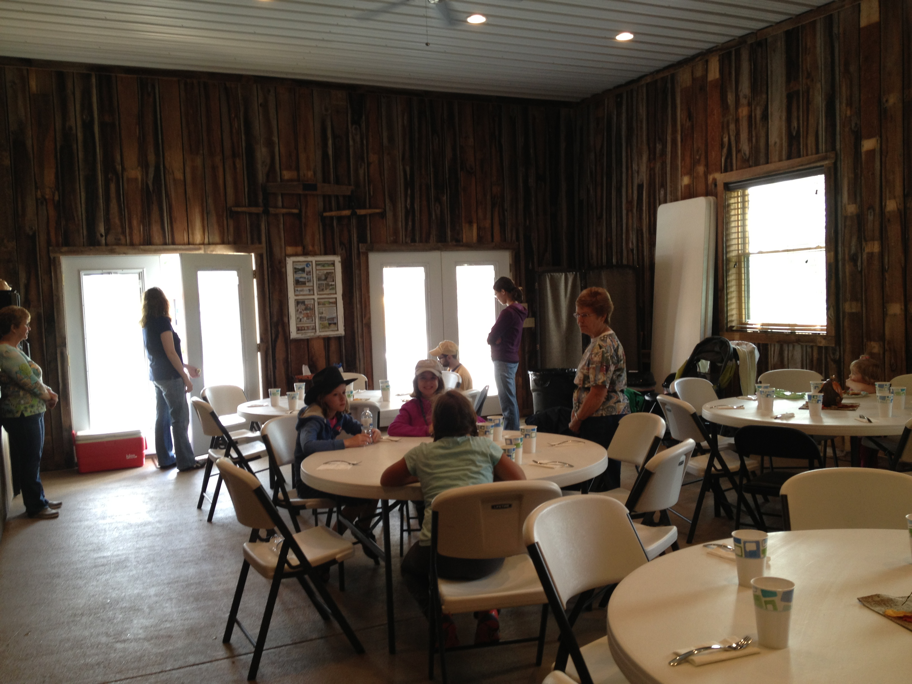
As only God can do, He provided a wonderful team to join the staff of The Springs, Scott and Amy Zabel. In January 2013, Amy relocated from their home in Illinois to The Springs and brought their two horses. Scott remained behind, hopeful for a transfer with the US Postal Service. The Zabels oversaw the process of putting the work processes of the Springs into systems and helped to continue the work Jon and Pennie had started. They oversaw the creation of a new ‘Gathering Space’ for large group meetings of up to 30-35 people, the building of a new campfire area out in the meadow. A new ‘community garden’ was begun providing fresh vegetables and fruit for our guests. After 10 months of driving back and forth on weekends, Scott and Amy decided to return to Illinois and re-establish themselves in ministry there. The imprint of their work will be felt for decades and they continue to live out the tag line returning to the Springs for SOS Workdays and special events.
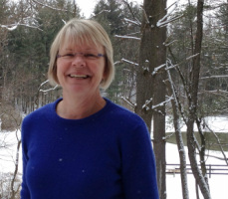
During our Fall SOS Workday in 2013, a wonderful volunteer, Britt Brown, was noticed by all for her work and love for The Springs. In October 2013, Britt agreed to help us by becoming our Interim Operations Manager for 3 months. Before that time was up, she was hired as our Full-time Operations Manager. Britt has continued to help make the Springs a place of beauty and peaceful rest. As a certified Master Gardener, she brings those skills to bear on the landscape and in the Community Garden. Britt’s children and grandchildren frequent the Springs enjoying all the benefits of nature’s best.
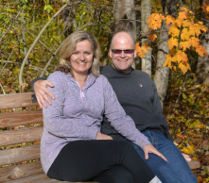
In July 2014, the Board of Directors expanded its number to include John and Joan Kelley of the Chicago area. The Springs holds a special spot in the hearts of John and Joan as they have visited frequently. Their experience of living on farms and as technical engineers allows them to feel at home at The Springs as well as to provide wisdom and direction.

The Spiritual Thread from the early beginning of the Springs
In doing the research on the property at 8173 Davison Road, it was my desire to see if there might be a ‘Spiritual Thread’ somewhere amongst the history of The Springs. To my delight, many of those that owned this property appear to be God loving and God fearing people. One church had it’s first meeting on the property and the initial owner of the land was an active member of the church where Lyman Beecher, father of the famous author, Harriet Beecher Stowe, preached. Here is a bit of the thread that was discovered.
- 1836 - Stephen Schooley was a member of Second Presbyterian Church of Cincinnati where Lyman Beecher was the pastor.
- 1841 - Elias Ward, whose ancestors had been good old Presbyterians in New Jersey, was a staunch Methodist and the first church services at Stipps Hill were held in his home. (This home was likely on the property later known as The Springs.) He was instrumental in having a meetinghouse built and a circuit preacher obtained so regular religious services might be held. This was likely a ‘Methodist-Episcopal’ Church and Elias and Rhoda were known for their Christian training of their children.
- 1876 - Aaron Ailes (Fletcher’s Dad) and his wife Elizabeth (Duvall) moved to Franklin County from Pennsylvania in 1837 and settled on a farm. Along with farming, he opened his home for ‘religious services’ and itinerant preachers always found a hearty welcome at his fireside.
- 1912 – James and Katie Herbert were active parishioners of St. Anne’s Catholic Church in Hamburg.
- 1989 - Vern and Phyllis King were active leaders in the Assembly of God Church and had the vision, heart and resources to create “King’s Ranch” in 1999 for those serving in ministry to some and be restored from their daily burdens in leading the church.
- 2010 - Dick and Sibyl Towner, Skip and Linda Holmes bring Spiritual Listening and Direction along with retreat ministry.
- 2012 – A labyrinth is built in the upper meadows to encourage slow, prayerful walks with God.
- 2014 – A cross is built and place on the far side of the lake. In January 2015, on a moonless night, John Kelley takes a time-exposed photo of the cross and a light unseen by the naked eye pours down upon it from above.

Board of Directors and Staff of The Springs, Summer 2014
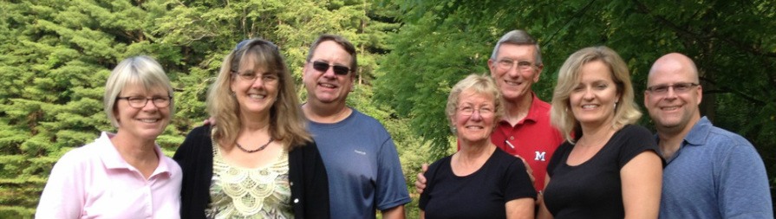
L to R: Britt Brown, Linda & Skip Holmes, Sibyl & Dick Towner, Joan & John Kelley

As researched and recorded by,

E. L. Skip Holmes, Director
January 2015

My thanks to:
- Pam Beneker, Franklin County Recorder, Brookville, IN
- Julie Schlesselman – Genealogy Librarian, Brookville, IN Public Library
- Linda Holmes and John Kelley – For their awesome photos…

