A SPIRITUAL PRACTICE of EXAMEN:

God invites us to discern the footprints of the Holy, to rehearse the mighty deeds of God. —Richard Foster

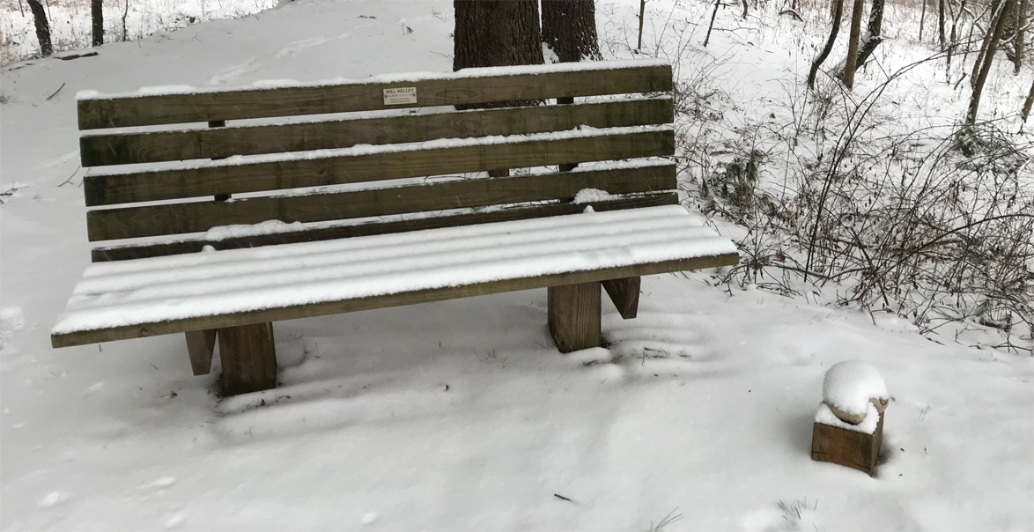

The examen makes us aware of moments that at first we might easily pass by as insignificant,
moments that ultimately give direction for our lives. —Dennis Linn

INVITATION:
The Daily Examen is an ancient practice focused on reviewing your day with God, noticing his presence with you and His deep love for you. It teaches you how to pay attention to where God is at work in the ordinary and extraordinary moments of your day.

SCRIPTURE:
Teach us to number our days, that we may gain a heart of wisdom. Psalm 90:12

PRACTICE:
Be Present with God: Notice and name how God is speaking to you in your daily life.

Give Thanks to God: Consider your activities, conversations and relationships and name specific places of God’s presence and provision. Express deep gratitude to God.

Reflect Back with God: Pay attention to your responses and emotions to each of the events and/or people. Did you find that you moved toward or away from God during these experiences or encounters? This awareness invites you to develop more positive responses to God and others.

Ask Forgiveness from God: Where you noticed that you moved away from God, confess your sorrow and ask for and receive His forgiveness.

Move Forward with God: Commit afresh to walk closely with God into the new day, a day and time He has never created before.

PONDER:
What happened in your day that gave you a greater picture of who God is or who he is crafting you to be?

Celebrating 10 Years of Retreat Ministry at The Springs - Joan Kelley, 2.2020

