A SPIRITUAL PRACTICE of LECTIO DIVINA:

“Lectio Divina is an opportunity to slow down and experience God's Word deeply…
to savor the words of Scripture, to sit at God's table, to be nourished, fed and refreshed…
to be fully present with our holy God.” ― Cindee Snider Re
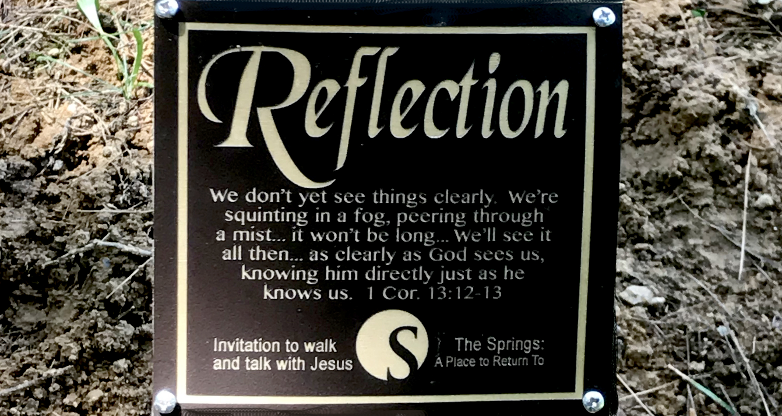
“Seek by reading and you will find by meditating. Knock by praying, and it will be opened to you in contemplation.” —St. John of the Cross

INVITATION:
Lectio Divina, divine or sacred reading, opens us to a life-transforming encounter with God within the biblical text. It invites us into a slower and more reflective reading of the Scriptures, allowing God to address us directly according to what he knows we need. —Shaped by the Word, Robert Mulholland

SCRIPTURE:
“Do not fear, for I have redeemed you; I have summoned you by name; you are mine. When you pass through the waters, I will be with you; and when you pass through the rivers, they will not sweep over you.
When you walk through the fire, you will not be burned; the flames will not set you ablaze. For I am the Lord
Your God, the Holy One of Israel, your Savior… —Isaiah 43:1-3 NIV
PRACTICE:
Slowly , meditatively, read aloud the chosen scripture before each step:
READ Listen for the word or phrase that is addressed to you.
REFLECT How is my life touched by this word or phrase today?
RESPOND What is my response to God based on what I have read and encountered? This is an opportunity to have an honest conversation with our Triune God— Father, Son, and Holy Spirit.
REST Simply rest in the Word and divine presence of God.

“When we engage the Scriptures for spiritual transformation, we engage not only our mind but also our heart, our emotions, our body, our curiosity, our imagination, and our will. We open ourselves to a deeper level of understanding and insight that grows out of and leads us deeper into our relationship with the One behind the text. It is in the context of relational intimacy that real life change takes place.”
—Ruth Haley Barton

Celebrating 10 Years of Retreat Ministry at The Springs —Sibyl Towner, 3.2020

