A SPIRITUAL PRACTICE of BREATH PRAYER:

“The breath prayer lies within us like a tiny seed that, when nurtured, grows and flowers, providing a new and deeper awareness of God’s presence.” Ron DelBene
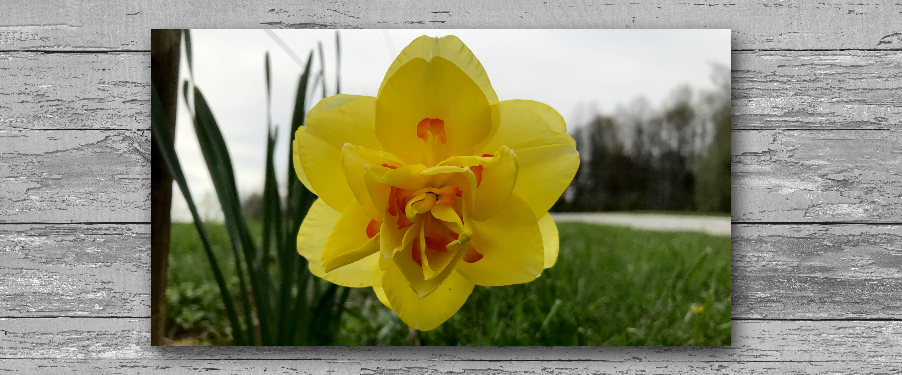
“The fullness of joy is to behold God in everything.” Julian of Norwich

INVITATION:
To “pray without ceasing” is the will of God and a challenge to live out. The invitation to connect the cadence of breath with a short prayer (7-8 words) acknowledges our relationship with God and a silent expression of a deep and personal cry of our heart. Pausing, slowing, repeating it frequently throughout your day, it becomes as familiar, natural and life giving as your own breath. Praying becomes less an act and more an embodied reality – an experience of oneness with God who lives His life and love in and through you. It can be a phrase from scripture or an expression of your own deep longing. Historically the most familiar breath prayer is from the words of the tax collector crying out (Luke 18:13): Lord, have mercy on me, a sinner.

SCRIPTURE:
Rejoice always, pray continually, give thanks in all circumstances; for this is God’s will for you in Christ Jesus. 1 Thessalonians 5:16-18
PRACTICE:
- Consider how you most comfortably address God: Father, Abba, Jesus, Good Shepherd…
- Rest quietly before God as He asks you, “ (Your name), what do you want?” John 1:38
Form a brief response, 3-6 words, that reflects a deep longing of your heart, such as:
Carry me in my weakness, Grant me peace, Teach me your ways, Guard my thoughts and words
- Combine the two: (breathing deeply, slowly)
  - Inhale, silently addressing God – allowing His presence to fill you;
  - Exhale, release the prayer or cry of your heart to Him.

Take your time to find the words that come from God for you. As He forms them, so they will form you over time. May your breath prayer help lead you into a life of prayer without ceasing, full of rejoicing and gratitude, enabling you to do His will throughout your day in your ordinary every day moments.
“Father in Heaven… Your will be done…” Amen.

Celebrating 10 Years of Retreat Ministry at The Springs —Linda Holmes 4.2020

